**Automatic Challan Generation**

**Introduction:**

Two-Wheelers account for the most number of road accidents. Though careless and rash driving is the main cause of these accidents, head injuries form a single largest reason for the road accident deaths. Study shows that more than one- third who died in road accident could have survived if they would have worn a helmet, the usage of helmet can save accident deaths by 30 to 40%. The rate at which preference of two wheelers in India is growing is 50 times the rate at which human population is growing. The risk of death is 2.5 times more among riders not wearing a helmet as compared to those wearing helmet. Speed is also not the main cause for motorcycle accident death study reveals that a fall from motorcycle even at slower speed can cause head injuries. Imagine a motorcycle travelling at a speed of 55km per hour, which means bike, is covering 49 feet per second. The impact of fall from the motorcycle at this speed is equal to that of a fall from fourth floor of a building. Taking into account importance of wearing a helmet Government has made compulsory to wear a helmet while riding a motorcycle but many of the traffic rule violators do not obey them. Nowadays video surveillance based system has become an essential equipment to keep a track on any kind of criminal or anti law activity in modern civilization. A Law enforcement agency has deployed large network of CCTV cameras covering all sensitive areas of cities like airport, railway station and road network. The road traffic monitoring is the most important part for detecting the traffic rule violators tracking criminals, etc. The existing video surveillance based system is effective but this system involves large number of humans who performance is not sustainable over long periods of time. Recent studies shows that human surveillance is not efficient as the duration of monitoring the video increases the errors made by humans also increases. And at some places as police Cops are manually clicking the photos of the violators not wearing the helmet in such case human biasing also comes into picture and its efficiency also decreases with large or dense traffic. So, automation of this process is on high requirement for reliable and robust monitoring of these violators. To make smart city many countries are adopting surveillance cameras at public places for 24x7 security monitoring. So, this automated solution for detecting the traffic rule violators is also cost-effective as it will use the existing video surveillance system. The algorithms present are neural network algorithm for detecting the presence or absence of helmet and (OCR) Optical Character Recognition and neural network for tracing the license number plate as compared to traditional methods which uses handcrafted features SIFT (Scale Invariant Feature Transform ), HOG (Histogram of Oriented Gradient), SVM (Support Vector Machine ), LBP (Local Binary Pattern ) for detection. Neural network has gain much more attention in complicated tasks such as image classification and has not been explored till date for such classification. The paper is organized as follows, Section I contains the introduction of the current scenario of the motorcycle accidents on public roads and the techniques or solution to overcome it.

**1.2. Objective of Research:**

The main aim is to develop a system which will detect whether the person is wearing helmet or not and whether the no of persons in bike is exceeded by 2 or not using cnn model.

**1.3. Problem Statement:**

Automatic Challan Generation using CNN model for detecting if a person is wearing helmet or not and triple riding or not.

**1.4. Industry Profile:**

The model developed here is used in traffic management. As discussed in the introduction section two wheelers record more accidents and rule violations. Many two wheelers will not care the traffic signals and road rules. It is very difficult to a traffic police to notify all the people who violate rules and keep a challan for them and if once people escape from challan they will repeat the mistake again. So this model helps to charge automatic challan to the persons who violate rules like not wearing helmet and triple ridding etc.

**2. Review of Literature:**

Wen et al. suggested circle arc detection method based on Hough transform. They applied it detect the presence of helmet on the surveillance system of Automatic Teller Machine. But the drawback of this work was it has used only the geometric features to detect the presence of helmet. Geometric features are not enough to detect the presence of helmet; many times the head can be mistaken with the helmet. In Chiu et al. It has used computer vision based system which aims to detect and segment motorcycles partly occluded by another vehicle. Helmet detection system was used in which presence of helmet simplifies that there is a motorcycle. In this paper to detect the helmet edges were computed of the possible helmet region.

**3. Data Collection:**

The data all we need here are images to train the model. We use CNN (convolution neural networks) model to develop a system which can predict if the person is wearing helmet or not. So for this we need images of persons wearing helmet and also not wearing helmet. We searched for datasets at different websites like <https://www.kaggle.com/> and <https://data.world/>. We prepared dataset by downloading pictures from Google .We downloaded almost 400 images and made a dataset with train and test data sets.

**4. Methodology:**

Here is an approach for automatic detection of motorcyclists without helmet in surveillance videos. And in case if the motorcyclists are not wearing the helmet then we will trace the license number plate of the vehicle .The process involves three phrases. In the first phrase we will detect the motorcycle in the surveillance videos. In the second phrase we will locate the head of the motorcyclists to detect whether the motorcyclists is wearing a helmet or not. In the third phrase if the motorcyclists is found without helmet then trace the license number plate of the motorcycle. The steps involved are as follows:

Step 1: Breaking down of an image the first step of breaking the image consists in cutting the image in smaller, overlapping images of equal sizes. In the figure 13, an image has been broken down in 77 overlapping tiny images of equal size.

Step 2 :Feeding of a tiny image to a small neural network For the second step, all the tiny images are fed to a small neural network that is going to analyze it and see if the expected item is present or not.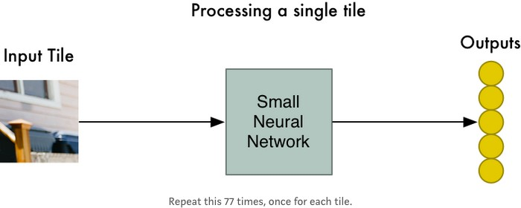 Weights keeping the same environment between images help to process them all the same way.

Step 3: From an array of images to an array of results after processing.

The results of each image fed to the neural network are stored in a new array. Because of that, the arrangement of the original tiles is kept. It is important to keep the arrangement of the tiles like the original image because we want our machine to think the same way as humans. The closer two individual images are, the more related to each other they will be. If we shuffle the order at this point, the correlation between the relative position and the relation between pictures would be lost.

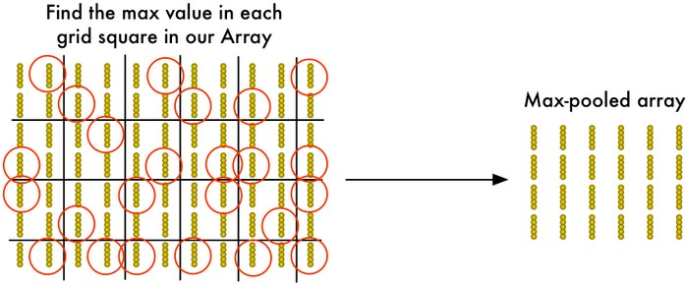Step 4: Down sampling

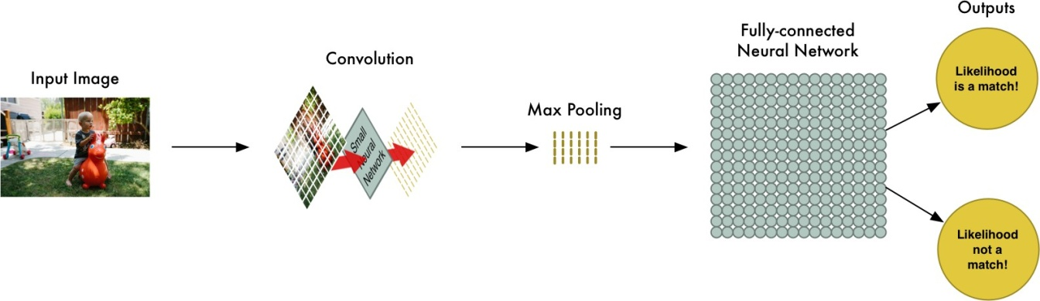The above figure illustrates the concept of down sampling. Because the order has been kept, the array is divided in 2x2 grid squares and from those small parts, only the most interest- ing output, being the one with the best similarity to the expected output, is kept.

**4.1 Figures and tables:**

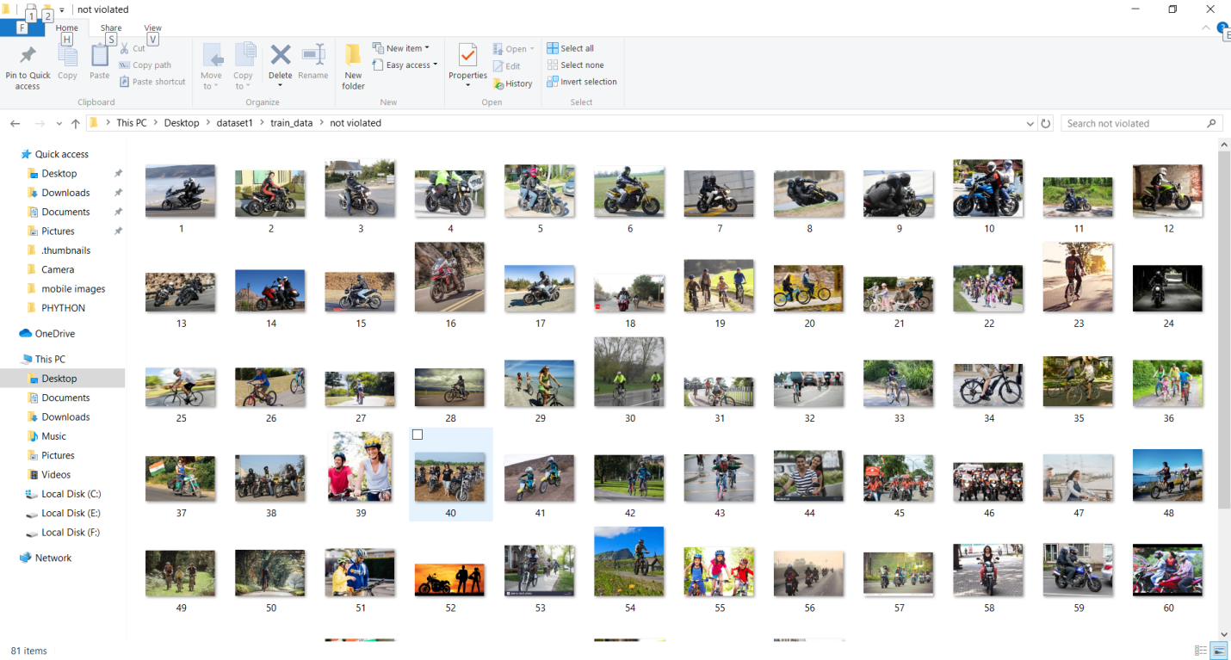

**4.2 Data Modeling:**

In applying cnn model to the data collected we use keras package in python. The steps will be as follows:

Step1: Convolution.

The output of this step is featured map where the image is converted into a matrix form and featured map is the output of this particular layer. We used a sequential model and conv2D to break and convert given image into a matrix which gives featured map as output.

Step 2: Maxpolling.

In maxpooling featured map is converted to pooled featured map by collecting major features from the image in other sense we can say eliminating background of the image. This process is done by taking maximum values or repetitive values from the featured map. The featured map is always of size 2x2.

Step3: Flattening.

Although we use CNN model in the last we need to convert it to ANN model. By using CNN we convert images into inputs which are to be given to the ANN model. Here we create input and hidden and output layers using dense function. There can be n number of hidden layers which increases the accuracy of the prediction.

Step4: Full Connected

Here ANN model is used to predict the values by taking the given inputs. In we ANN have one input layer and n number of hidden layers. In ANN we have many iterations we can run n number of epochs which increases the accuracy of the model. The below figure illustrates the deep learning process that is used in cnn to analyze data and predict output.

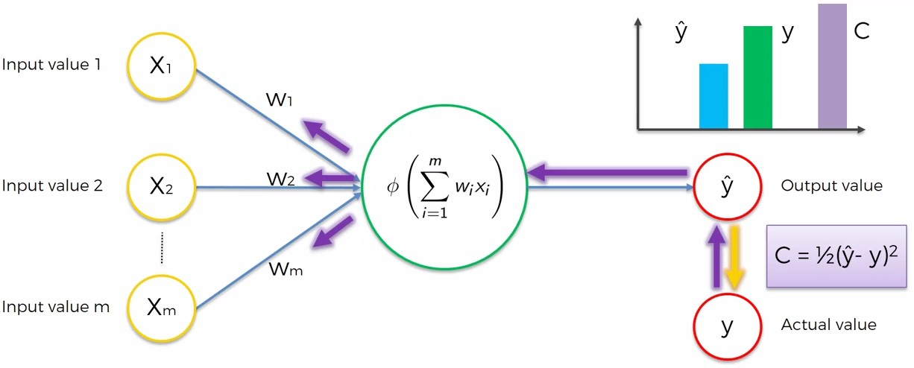

**GUI**

We used tkinter package from python to fetch the given image (as we giving input as image) and predict the output.

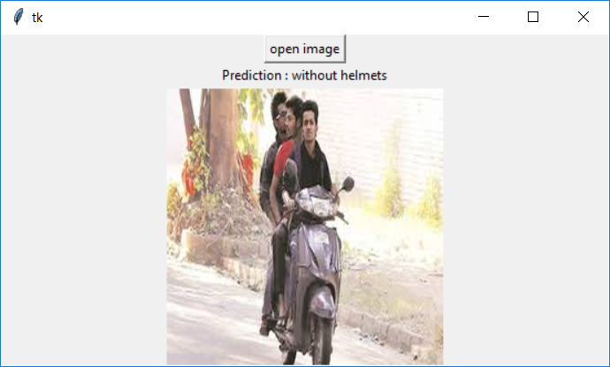

**5. Findings and Suggestions:**

The limitations in this model is we can’t combine a ANN model with any other models and while processing the image there may be many impossibilities and sometimes there may be error while processing.

**6. Conclusion:**

In this model we take a traffic picture as input and then using cnn model we predicted if particular vehicle violated rules by not wearing helmet. This model will be helpful in traffic management but it cameras must be automated to use this model and many developments must be done to improve the accuracy rate of this model. In future there may be chance of improvements in this model to make model more accurate.